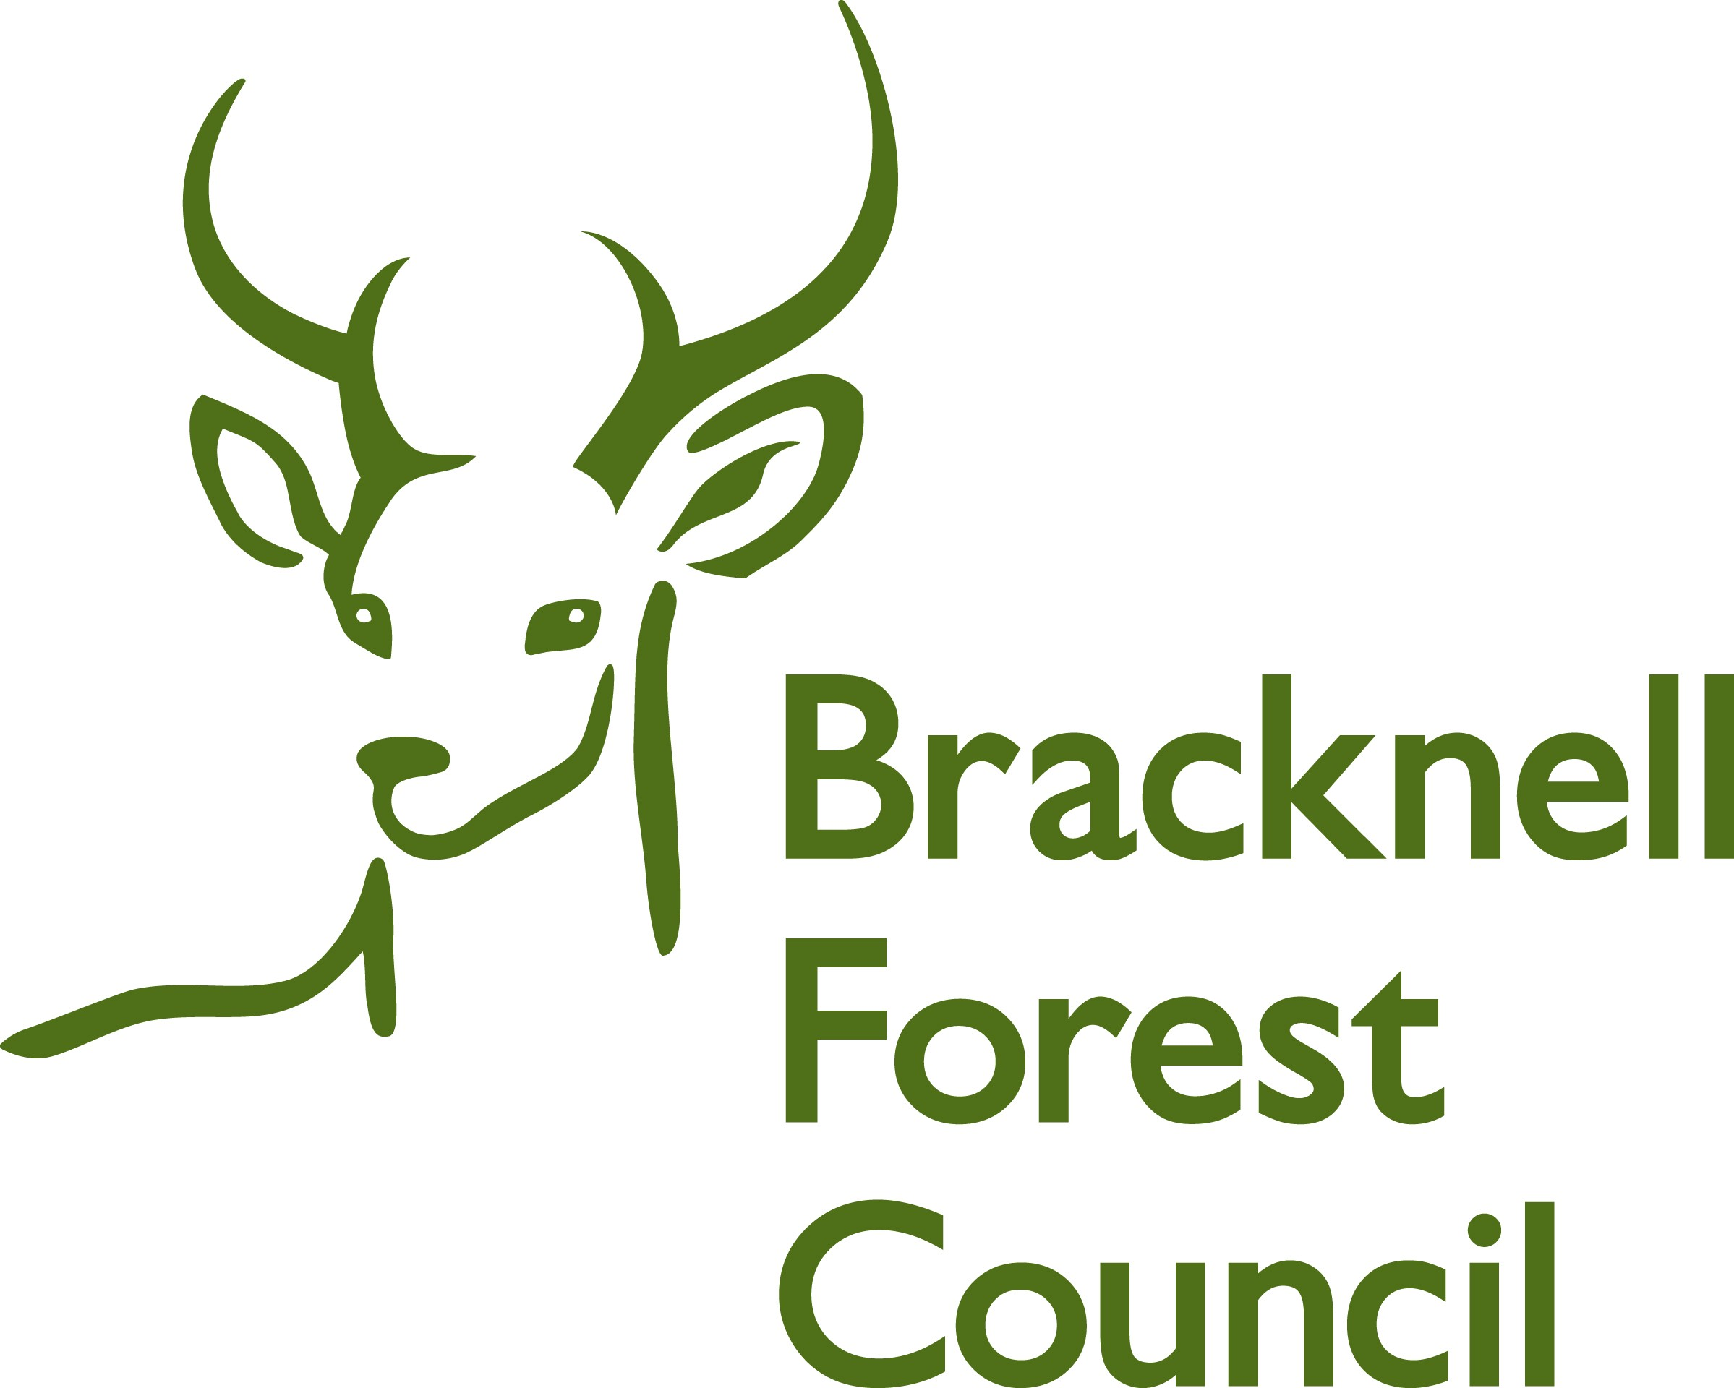

Season Ticket application form

This form is for the purpose of applying for a Season Ticket loan.
The season ticket loan scheme aims to encourage staff to use public transport for their journeys to and from work through offering an interest free loan to buy a season ticket
Scheme Details;
- Available to all employees, except those on fixed term contracts for less than a year, casual or temporary employees, employees who already have a car loan, or receive an essential user allowance
- For season tickets on train season tickets
- The loan is interest free – covering the full cost of the season ticket
- Minimum loan size is £100 and maximum £5,000. (Loans under £5,000 are treated as “tax free” by the Inland Revenue)
- Loan available for 12 months only
- Payment by cheque – must be made out to public transport undertaking, eg: Thames Trains
- Loan recovered by equal monthly instalments deducted from pay. Please note that the recovery of the loan must be made before the expiry of the season ticket.

Please note that the recovery of the loan must be made before the expiry of the season ticket.

Name:
Payroll number:
Department: | Chief Execs / Delivery / PPR / People / Resources *
Phone number:
Home address:
(season ticket will be sent to this address)
Email address:
*Delete as appropriate

Loan details

Value of loan applied for:  National Rail Enquiries - Season Ticket Calculator | £
Start date of season ticket:
End date of season ticket:
Number of days per week:
Journey from:
Journey to:
Please specify the train company:

Terms and conditions
If my application is granted I agree to the following terms and conditions of the loan with Bracknell Forest Council:
- I will use the season ticket regularly to travel to and from work, and that it will be my principal means of travelling to and from work
- I will repay the loan advance and the postage charge to the council by equal monthly payments which I authorise the council to deduct from my salary for the duration of the season ticket, starting with the first payment of salary after the loan is made
- I agree that any monies owing by me to the council may be deducted from my salary should I leave the council before the full repayment has been made.
- I agree that should my salary not cover the outstanding balance, I will pay the balance before leaving the employment of the council
- In the event of my cancelling or surrendering the ticket before its expiry I will repay to the council the outstanding amount of the loan in full immediately
- That any loss of the ticket will not relieve me of the liability to repay the loan in full to the council – it is strongly advised for employees to take a photocopy of their ticket to help protect their interests, in the event of a lost ticket

To confirm your understanding and acceptance of the terms and conditions of the Season Ticket Loan scheme as set out above please sign below.
I consent to my name, address details and photocard number provided to the train company to enable the season ticket, to be sent to my home address.

Signed …………………………………………..

Dated ……………………………………………

Once completed please return to hr@bracknell-forest.gov.uk

