
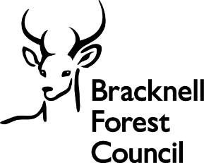

Employee referral form

- To refer a potential employee, fill in the employee and candidate information fields below.

- Then email the document to: recruitment@bracknell-forest.gov.uk

If the candidate referred has selected ‘referred by a friend’ on their application form and is successfully appointed, you will receive a referral payment of £500, in two instalments, subject to deductions for pension, tax, and NI, as applicable.

Employee information – making the referral

Employee name:
Team/department:
Email:
Date submitted:

Candidate information

Name of candidate:
Position applied for:
Jobs Go Public Reference:

Recruitment team use only

Date received:
Candidate successful: | Yes/No

Cost centre:
Candidate’s start date:
First payment date:
Resourcing officer:

Date of six months employment:
Second payment date:
Resourcing officer:

