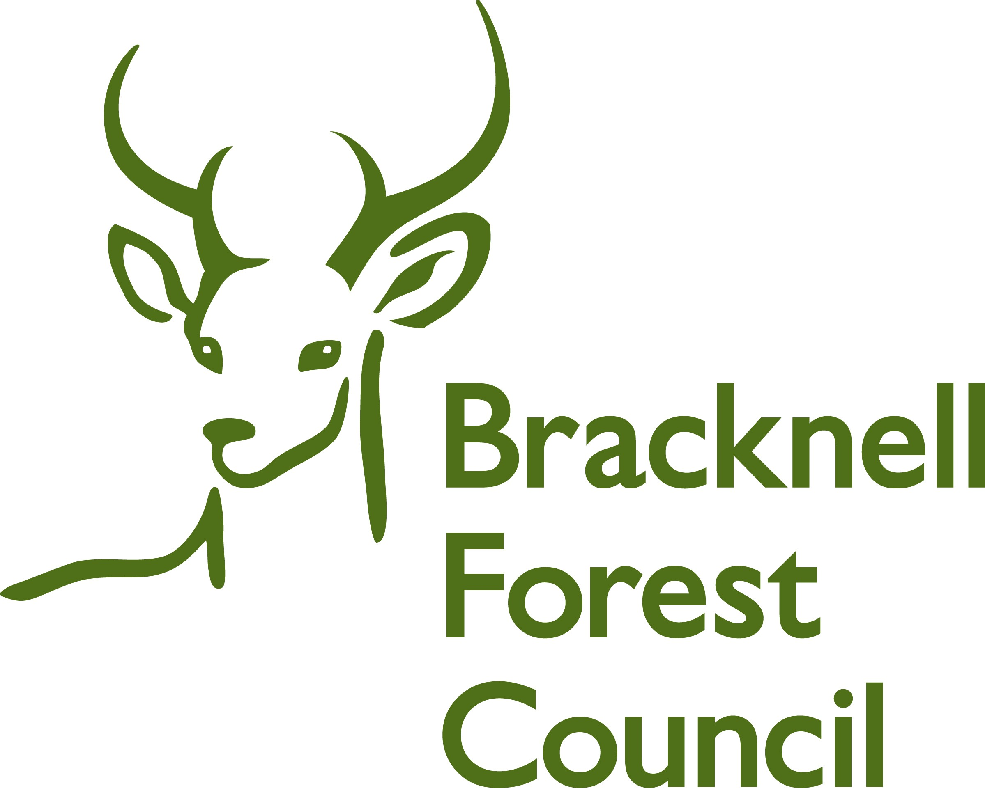

# **Who’s In Charge referral form**

|  |
| --- |
| **Who’s in charge is a parenting course to support parents/carers who are struggling with their child’s abusive behaviour.**  **The course runs for 8 weeks, for 2.5 hours. Courses are Wednesday evenings 6-8.30pm or Friday mornings 9-12.30pm.**  **Location Zone 76, Priestwood Court Road, Bracknell, RG42 1TU**  **Please note the young person should be aged 10 – 18 years.**  **Parents should have completed other parenting first, i.e. STOP.**  **However please speak to facilitators as their discretion can be used to assess suitability of referral.**  **Please send all referrals to** [**youth.justice-team@bracknell-forest.gov.uk**](mailto:youth.justice-team@bracknell-forest.gov.uk) |
| **Young person name: -**  **Address: -**  **DOB / Ethnicity: -**  **Siblings name & DOB / Ethnicity in the family home: -**  **School: -**  **Parents/carers details**  **Mobile: -**  **Email address: -**  **Please tick preferred day:-**  **Monday evening  Friday morning** |
| **Referrer/Self -referral**  **Name: -**  **Role: -** |
| **Please provide details of child to parent abuse and give example: -**  **How long has this behaviour been displayed: -**  **Other services supporting (i.e. Children Social Care / CAMHS / Early Help / Youth Justice Team): -** |
| **Other Information if relevant, (i.e. if there are police contacts / have they complete other parenting / health conditions etc: -** |
| **Parent/carer signature: - Date of referral:** |