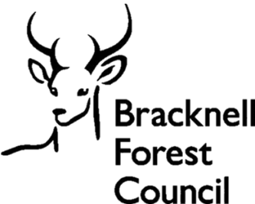
Suggest a biodiversity project

This form collects personal data including names and contact details. Providing this information is optional, but if you do not provide it we will not be able to contact you to request further information or keep you updated on progress.

By providing this information, you consent to us processing your personal data for this purpose in line with our privacy policy, and this form also gives you the chance to sign up to mailing lists to hear about other opportunities.

If you wish to change your preferences at any time, email climate.change@bracknell-forest.gov.uk.

A: About you (optional)
Name |  | Click or tap here to enter text.
Are you suggesting this project on behalf of an organisation? |  | Yes ☐/ No ☐  If yes, please complete the questions on your organisation below.
 | Name of organisation/group |  | Click or tap here to enter text.
 | Type of organisation |  | Click or tap here to enter text.
 | Charity or company number  (if applicable) |  | Click or tap here to enter text.
 | Address |  | Click or tap here to enter text.
 | Your job title or position |  | Click or tap here to enter text.
Email address |  | Click or tap here to enter text.
Phone number |  | Click or tap here to enter text.
Mailing list sign-up |  | I consent to being added as a contact to the climate change mailing list to hear about relevant opportunities in future (optional)  Yes ☐/ No ☐

B: Site and project information
Address or location | Please be clear about the parcel of land you mean – for example by providing a What3Words location and a description of the boundaries.
Site details | Please include the site size and information on the current use and features. If possible, please attach maps and/or photos of the site.
Is the site publicly accessible? | Yes ☐/ No ☐
Suggested site improvements | Please describe the improvements you would like to see made to the site in as much detail as possible, with reference to maps or photos of the site if available.
Do you have any information on the cost of improvements? | Yes ☐/ No☐  If yes, please provide details.
What will the benefits of the project be? | For example, this can include benefits to nature and biodiversity, to the community or to climate adaptation.

C: Delivery
Are there any issues with access to the site? | Yes ☐/ No☐  If yes, please provide details.
Do you own and manage the land? | Yes ☐/ No ☐  If not, please provide as much information as possible on the ownership and management of the site.
Would permission from other stakeholders be needed to progress the project? | Yes ☐/ No ☐  If yes, please provide as much information as possible on the stakeholder, their role and any engagement to date
Have you engaged local residents about this scheme? | Yes ☐/ No☐  If yes, please provide details.
Are you interested in providing a financial contribution towards the scheme? | Yes ☐/ No☐  If yes, please provide details.
Are you interested in supporting the scheme in other ways such as maintenance? | Yes ☐/ No☐  If yes, please provide details.

